
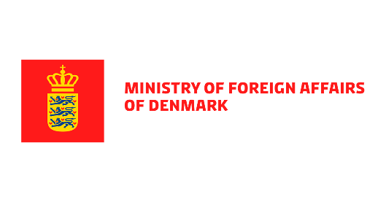
Third Project Advisory Committee Meeting
ILO-DANIDA project “Inclusive Labour Market for Job Creation in Georgia”
2 March 2021, 14:00 – 16:30 Tbilisi time

Agenda
14:00 – 14:20 | Opening Remarks:  - Ms. Tamuna Barkalaia, Deputy Minister, MoIDPLSA  - Mr. Elguja Meladze, President, GEA  - Mr. Irakli Petriashvili, President, GTUC  - Mr. Mikael Erbs, DANIDA
14:20 – 14:25 | Introduction of the new Chief Technical Advisor, Mr. Catalin Tacu.
14:25 – 15:05 | Presentation of Project Progress and Q 1 and 2 Work plan:  - Component 1: Improved enforcement and respect for labour laws and international labour standards  - Q&A
15:05 – 15:45 | Presentation of Project Progress and Q 1 and 2 Work plan:  - Component 2: Promotion of youth entrepreneurship and responsible business practices.  - Q&A
15:45 -16:05 | Any other business
16:05 – 16:30 | Concluding remarks

